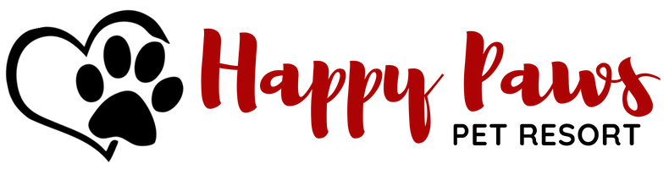
Happy Paws’ Day Care provides a safe, leash free environment that allows dogs the opportunity to play, bark and run all day. Below are a few items to note if your dog attends our Doggie Daycare:
- Dogs are social animals as well as instinctual pack animals. They will be playing in close physical contact with each other. This includes play involving teeth and nails. Even under professional supervision, scrapes, nicks and punctures may occur. In the event of an injury, we will contact you immediately (unless otherwise stated on your Client Profile) as well as inform you of the incident when you pick your dog up from the Daycare.

- Our leash free environment allows the dogs to play in close physical contact with each other. This closeness increases the risks for the spread of communicable disease. No amount of sanitation, personal care or vaccination requirements can be 100% effective against the spread of communicable illnesses.

- Water is always readily available in several areas throughout our daycare. However, your dog may be too distracted or excited by play to drink on a regular basis. This may lead to excessive drinking when they return home. Make sure to monitor your dog’s water intake as excessive drinking can cause an upset stomach.

- Some dogs need a “Time Out” on occasion. This is due to overexcitement, excessive fatigue or aggression. Your dog will be separated from the pack for a short period of time for them to settle down. This “Time Out” policy is done to help control the dogs as well as to minimize and potential problems or injuries, either to other dogs or staff members.

- During the summer months, we keep the dogs as cool as possible. In the outside yards, we do use baby pools for the dogs that are permitted to get wet. Dogs at play do get dirty. Rain or snow can add to this. Bark Avenue makes every effort to send your dog home as clean and dry as possible. We do offer departure and spa baths. Feel free to call and schedule one for your dog.

